# Report for Tanner Kim (2024-10-01 to 2024-10-31)

Average Bat Speed: 49.79

Average Rotational Acceleration: 13.76

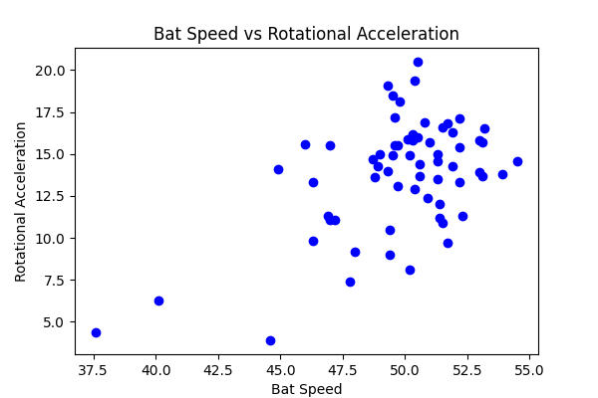

## Comments

Add comments here...